**WNY PCC NEWSLETTER**

**July 2018**

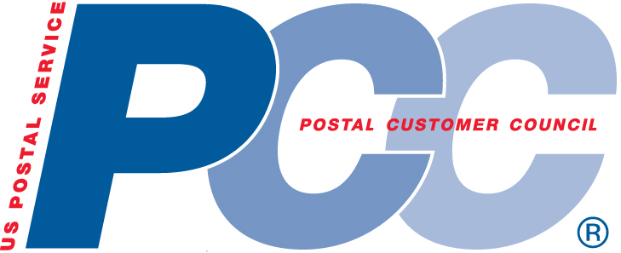

**&**

Greater Rochester PCC



**Priority Mail Flat Rate**

**Forever Prepaid Supplies**

Similar to personalized stamped envelopes, customers can order USPS Priority Mail Flat Rate Forever Prepaid Envelopes and Boxes.

Shipping labels with the customer’s return address and tracking information will be pre-printed and applied to the envelopes and boxes that are ordered. The postage applied is considered “FOREVER Postage” and good even if the Priority Mail flat rate increases.

**Priority Mail Supplies are available at** [www.usps.com/shop](http://www.usps.com/shop)**.**

**Shipping Options** – Priority Mail Forever Prepaid Envelopes – With Return Addresses and Tracking

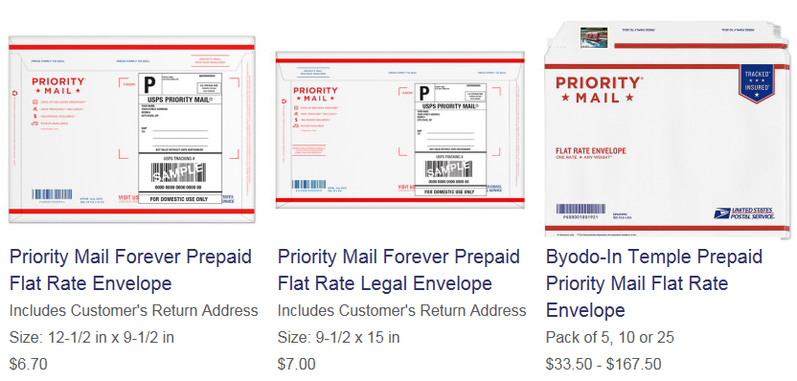

**Shipping Options** – Priority Mail Forever Prepaid Boxes – With Return Addresses and Tracking

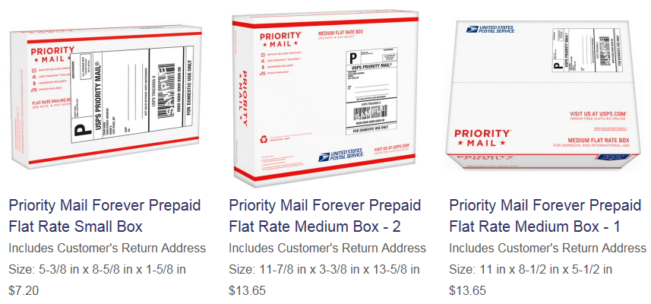

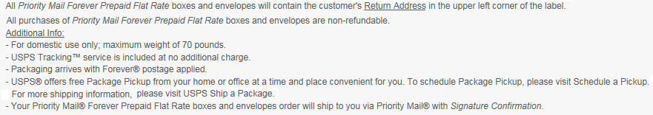



Upcoming Events

September 26, 2018 National PCC Week event at the **Batavia Country Club**

**Keep an eye out for more information!**

**Mail moment multiplier**

**USPS promoting services to businesses**

**[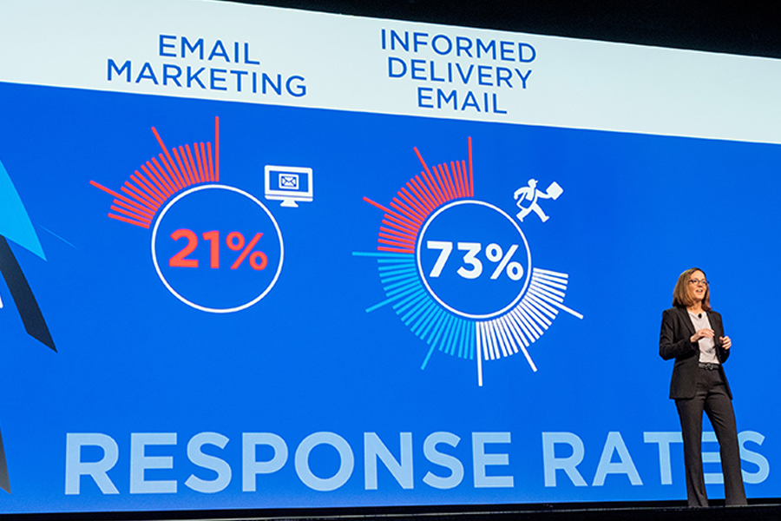](https://link.usps.com/wp-content/uploads/2018/05/NPFcustomer_large-story.jpg)**

Acting Chief Customer and Marketing Officer Jacqueline Krage Strako

The Postal Service is on a mission to showcase the value of mail, Acting Chief Customer and Marketing Officer Jacqueline Krage Strako told more than 4,000 customers at the National Postal Forum (NPF).

To achieve this goal, USPS will develop a marketing campaign to promote mail to the nation’s businesses. The campaign will emphasize the value that mail offers marketers, and how postal information platforms enable coordinated “omni-channel” marketing.

The campaign will also show how businesses can enliven their mailpieces by adding innovative features like “video-in-print” and augmented reality.

“In today’s omni-channel marketing, the mailpiece complements and triggers other media channels,” said Strako. “Mail engages all the senses. It’s tactile. It’s memorable. It draws on our emotions. … Consumers spend time with valuable content on their own terms — in their own homes.”

USPS is also working with businesses to use its mail notification service, Informed Delivery, in [new, creative ways](https://link.usps.com/2018/05/07/informed-innovations/). For example, companies can [add interactive content](https://link.usps.com/2017/12/05/riding-along/) to Informed Delivery emails. When a consumer clicks on this content, he or she will be taken to the company’s website to receive offers and coupons, and to learn more about its products and services.

“Informed Delivery is making everything in the mailbox even more valuable, and that benefits the mailing and shipping industry, and the Postal Service,” Strako said. She called Informed Delivery a “mail moment multiplier” because it gives users two unique experiences each day: once when they receive their Informed Delivery preview, and again when their physical mail arrives.

USPS continues to encourage interested consumers to sign up at [informeddelivery.usps.com](https://informeddelivery.usps.com/box/pages/intro/start.action) and experience the benefits of the feature.

**Contact Information**

**Buffalo Niagara PCC**

Email: [**BNPCC@usps.gov**](mailto:BNPCC@usps.gov)

**http://buffaloniagarapcc.org**

**Greater Rochester PCC**

Email: [**GRPCC@usps.gov**](mailto:GRPCC@usps.gov)

**http://greaterrochesterpcc.com**

**Terry Ringler**

**Customer Relations Coordinator**

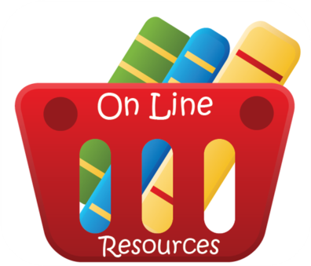**(716) 846-2536**

[**Therese.R.Ringler@usps.gov**](mailto:Therese.R.Ringler@usps.gov)

**Online Resources**

**Business Customer Gateway**

[**https://gateway.usps.com/eAdmin/view/signin**](https://gateway.usps.com/eAdmin/view/signin)

**Zip Code**

[**https://tools.usps.com/go/ZipLookupAction!input.action?mode=0&refresh=true**](https://tools.usps.com/go/ZipLookupAction!input.action?mode=0&refresh=true)

**Quick Service Guides**

[**http://pe.usps.gov/text/qsg300/q000.htm**](http://pe.usps.gov/text/qsg300/q000.htm)

**Mail Service Updates**

[**http://about.usps.com/news/service-alerts/welcome.htm**](http://about.usps.com/news/service-alerts/welcome.htm)

**PostalPro**

[**https://postalpro.usps.com/**](https://postalpro.usps.com/)

**National Customer Support Center**

**1-800-238-3150**

Article suggestions or ideas for upcoming newsletters please email either PCC.